1. Detailed Process Steps
   1. FOLDERS Creation Process
      1. Go the share drive create 4 folders as below
   2. BGCO_DDMMYY_Daily_New Equipment Only Download
      * 1. Download all the Center 1,2 &3 Orders in this folder, keep the naming convention as “BGCO_Daily_NEO_Center1_Center2_Center 3_DDMMYY”
   3. BGCO_NEO_Database_DDMMYY
      * 1. BGCO_New _Equipment_ Only_DDMMYY
        2. BGCO_Active_Pending_DDMMYY
   4. BGCO_Templates
      * 1. New Equipment Only - MTN_NEW_EQUIPMENT_TEMPLATE.CSV
   5. BGCO_Inbound_OutboundFile
      * 1. Create 2 folders as BELOW:
           1. Inbound folder (Incoming)
           2. Outbound Folder
        2. Always save the sheets filled in defined naming conventions as below:
           1. Naming Convention to save - “Incoming-WFM Number-process name-ECPDID- Client ID”
           2. Outbound_WFM_NewEquipmentOnly_ECPDID_CLIENT ID_APIRef#_Completed
   6. WORKFLOW Manager – Orders Downloading Process
      * 1. Login to WFM Tool – (“https://wfmqa1.vzwcorp.com/wfm/index.jsp”)
        2. Click on “Order Search”

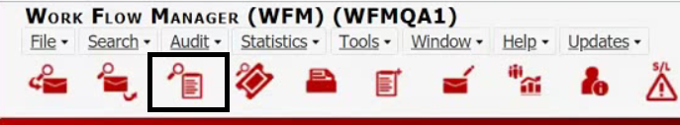

* + - 1. Select – Center (Active only) – Center 1,2&3 FROM the drop-down arrow (we can select one center at a time)
      2. BGCO SMB Shared
      3. GCO Federal Government
      4. GCO State Government
      5. Insert “Order Type” as – **New Equipment Only**”, That will pull the Order Search Results of Orders related to that particular process.
      6. Under – Status Info & Sort Section – Check the Radio Button “Ascending”, Select – Received Date

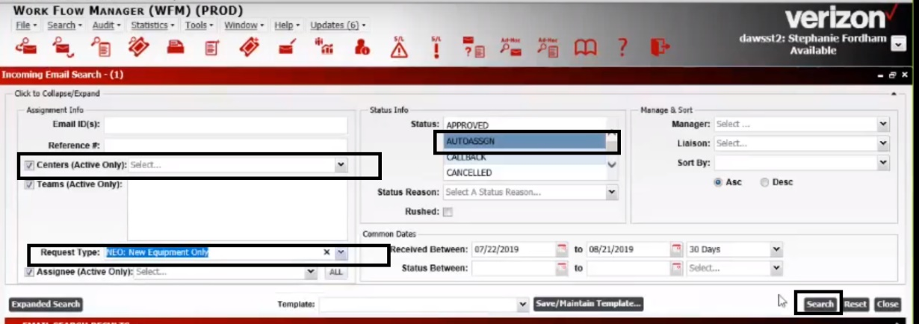

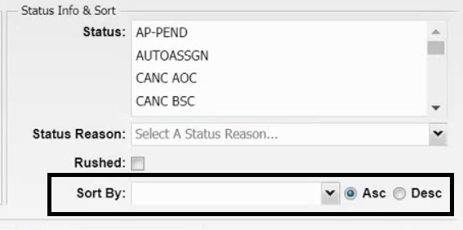

NOTE: All the Orders are processed in (First in First Out Basis)

* + - 1. Click on “Search” Tab, Scroll down to “Order Search Results” Section,

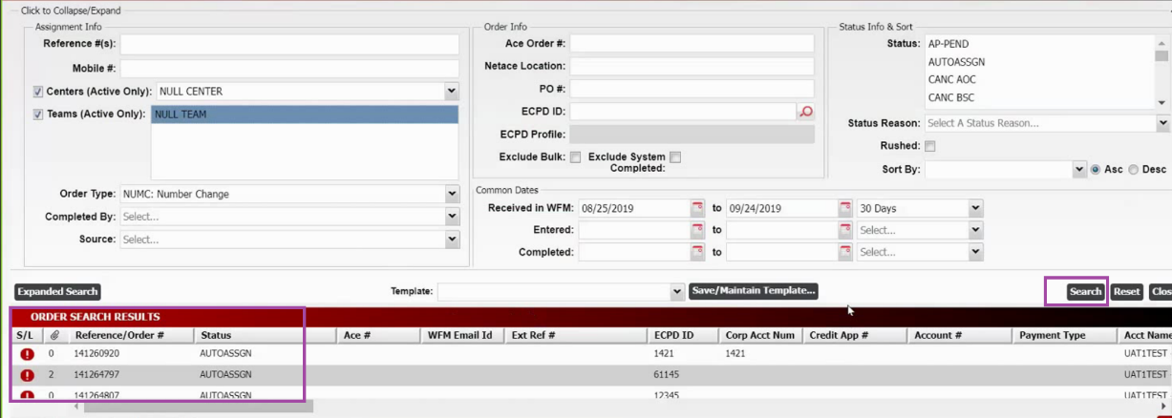

* + - 1. Right click on the Ref# and select “Export to Excel Table”
      2. All the order will be downloaded into an excel table (Local Temp folder) Ensure to save those files in the below step mentioned
      3. Open the downloaded and click on “Show in Folder” and rename the file as below “BGCO SMB Shared”/ “GCO Federal Government” / “GCO State Government”
      4. Save the file as BGCO_Daily_Order_Processing_Center1_Center2_Center 3_DDMMYY under Folder
      5. Close the WFM Tool

NOTE: Continue the steps from 7.1.3. to 7.1.7 till the Orders are downloaded from all the 3 centers, Close the WFM tool once this activity is completed.

* 1. WORKFLOW Manager – Orders Processing
     + 1. Go to Share drive FOLDER (BGCO_DDMMYY_Daily_Order_Download) & open Each file “BGCO SMB Shared”/“GCO Federal Government”/“GCO State Government”
       2. Copy the – Ref# and Time STAMP (Received date) column from the Sheet and paste it in the Database sheet, once it is done for all the three centers delete the files downloaded in folder (**BGCO_DDMMYY_Daily_Order_Download)**
       3. Copy the first “Reference#” from the spreadsheet (A Ref order number can have multiple MTN’s)
       4. Login to WFM Tool – (“https://wfmqa1.vzwcorp.com/wfm/index.jsp”)



* + - 1. Insert Reference/Order number and click on Search
      2. Ensure the Order status is in – “Auto Assign”
      3. Validate if the Order is assigned to team - “RPA Work Digital”
      4. If No – Close the Order and go back to excel to pick another Order
      5. If Yes – Select “Assignee “-” DWID” (Yet to get the Name)
      6. Click on ‘Save”
      7. On the Menu Bar – Click on “Print Item (Order/Ticket) It opens the Order Form – “User Information”

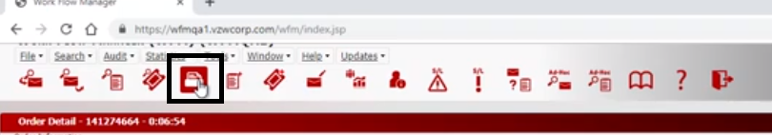

* + - 1. Below mentioned details are supposed to be captured for each type of Request. Capture the Below fields from the WFM Form, NOTE: A Ref can have multiple MTNs information in Order form
      2. New Equipment Only – Capture
      3. ORDER LEVEL
      4. ECPD
      5. Existing Account
      6. Shipping SKU
      7. Sales Rep ID
      8. Location Code
      9. Split Order for Line Level Shipment
      10. LINE LEVE
      11. Seq
      12. Order Type
      13. Mobile Number
      14. Sub Account
      15. New Price Plan
      16. Global
      17. New ESN MEID
      18. SKU
      19. Accessories
      20. Add Drop Features
      21. Reason Code
      22. Contract Term
      23. Primary Username
      24. Email Address
      25. Effective Date
      26. Ship SKU
      27. PPU Address
      28. Sales Rep ID